Name |  | Date

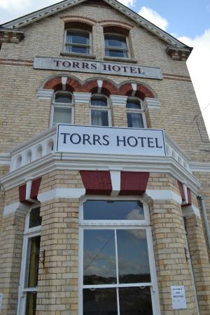
Case study & questions: The Torrs Hotel
After two years’ hard work renovating an old building, entrepreneurs Pam, Marie and Abu opened the Torrs Hotel in Devon to the public. This was a risk for all concerned, but with the room occupancy now at 90%, the decision to spend the time and money preparing the building for guests seems to have paid off.

The hotel is in a quiet part of town, but within easy reach of the town centre, sea front and shopping. This location helped the success of the business, but the determination of the owners is a critical factor, especially in a business where there is a lot of competition.

Questions
- Who are the entrepreneurs involved in the business and what do you think motivated them to set it up?

- What are the customer needs or wants that this business satisfies?

- What were the benefits of the hotels location to its customers?

- What risks did the entrepreneurs face when setting up this business?

- What characteristics did these entrepreneurs demonstrate when setting up the business?

- Would you prefer to set up your own business or work for one that has already been established? Justify your answer.

