My structure for business exam:
3x smart objectives
Rationale justification of the campaign, how it will be effective
Primary research: OBSERVATIONS, QUESTIONAIRES, FREE SAMPLES
Secondary Research: NEWSPAPER ARTCILES, WEBSITES, MARKET REPORTS
Analyse the research given in the pack and make key notes on the pack about any information that is given start to think of what are the positives and negative
reliability – how easily the research could be repeated and provide similar results
Validity – measure of how relatable
Marketing message – what you want to convey to customers
The 7 p’s:
Mention pricing strategy – competitor pricing, price skimming, penetration cost plus
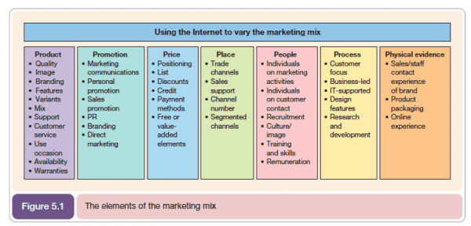
Pestle analysis –
Political - Tax policy; environmental regulations; trade restrictions and reform; tariffs; political stability.
Environmental – pollution, sustainability, renewable materials
Social - look at trends such as lifestyle factors, cultural norms and expectations
Technological - production techniques, information and communication resources, production, logistics, marketing, and e-commerce technologies.
Legal - Consumer law, discrimination, copyright law, health and safety law, employment law
Economic - exchange rates, economic growth or decline, globalisation, inflation, interest rates and the cost of living, labour costs and consumer spending
SWOT analysis – strengths, weaknesses (internal) opportunities, threats (weaknesses)

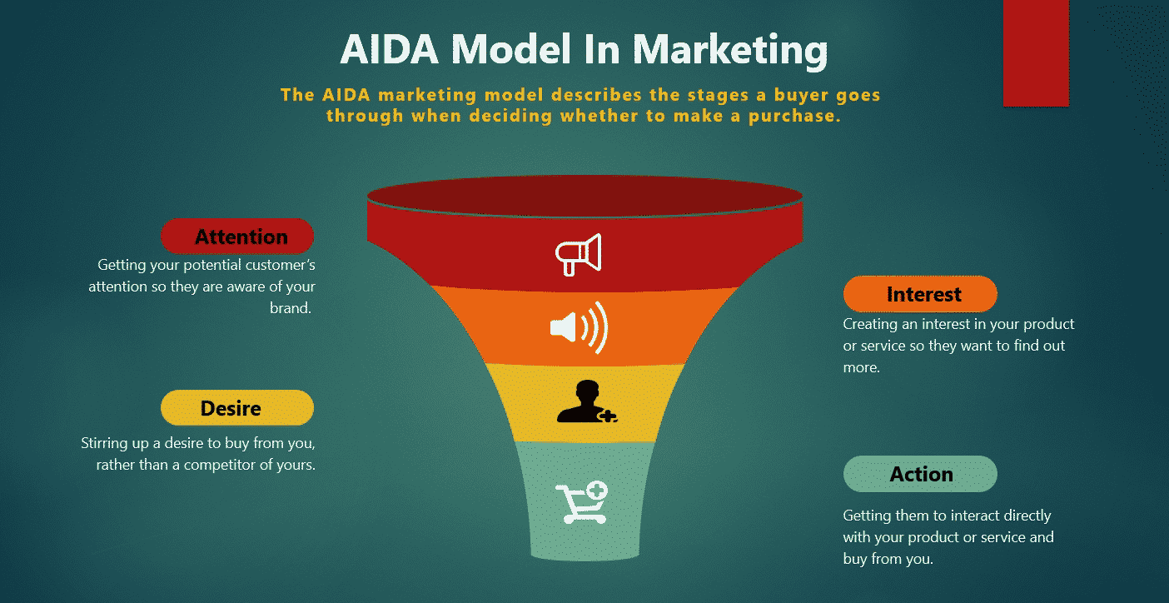

Type of media | Cost | Amount of budget being allocated | Number of weeks/times of year | Justification
YouTube ads
Bill boards
Instagram
TikTok – influencers
Time scale
Budget
Make a conclusion – write a brief paragraph explaining as to why this marketing plan will help the business achieve its aim of generating more revenue.
Information | Key data | What it means for the business?
Market size
Market growth
Competition

