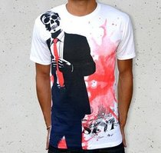
Case study: ML INC.
In 2017 Mona Lott, a fashion designer, set up her own clothing brand retailing direct to consumers via the internet. In her first year if trading, Mona focused on one item of clothing, t-shirts, which she retailed at £12 each. In her first month of trading ML INC. sold 347 units.
Questions:
1. What was ML INC.s revenue for the first month of trading? Please show your workings

2. How could Mona increase the revenue of ML INC.?
​

3. If ML INC.s costs for the first month of trading were £3,000 how much profit did the business make?

Stretch & challenge: What costs do you think ML INC. may have incurred during their first month of trading?

