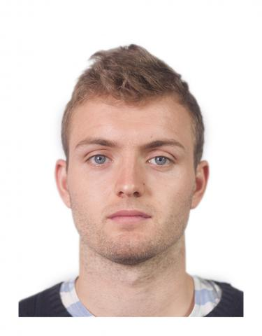
CV – Curriculum vitae
Name: Harry Harper
D.O.B. 12th September 2002
Address: 129 Longfields, Sandon, Essex, CM1 7AQ
Telephone: 01286 365490/07946386871
Email address: sparkyharpy@hotmail.co.uk

Personal statement
I am a dedicated and hardworking student currently studying in my second year at SandonSixth form. I am an enthusiastic student and always strive for excellent in pursuit of my academic grades. I am passionate about my studies and am a strong believer that hard work can overcome all obstacles in life. I work extremely well in teams both as a leader and as a follower as I believe that great companies are built upon working together and cooperation.
My personal passion outside wok is Rugby and have been playing for my local club since I was 8 years old. I also like to watch films and go to gigs with my friends

Achievements
- Won the 100 meter sprint at year 9 sports day
- Was honoured to meet (former ) MP Tristan Hunt when he visited my school
- 100% attendance at school for three years running (Y7 – 9)
- Runner up, Essex youth rugby cup
Experience
- Back Inn Time - Waiter
- Pizza Della Case - Chef
- The Royal London Hospital – Shadowing Consultant general surgeon
- Yellow Advertiser & Independent – Newspaper Distribution
- Goodey’s News – Paper Boy
Professional awards
None yet

Activities
- Writtle RFC
- Duke of Edinburg Bronze, Silver and Gold award
- Attended Download Fest every summer for past three years

Education and training
- Danbury St Johns Primary school (2008 – 2014)
  - No qualifications gained

- The Sandon School (2014 – 2019)
  - 9 X GCSEs

- The Sandon School Sixth Form (2019 – 2021)
  - 3 X A Levels
References
Available upon request

