Handout – The PLC (Product Life Cycle)
The product life cycle is an important concept in marketing. It describes the stages a product goes through from when it was first thought of until it finally is removed from the market. Not all products reach this final stage. Some continue to grow and others rise and fall.

Product Life Cycle
The main stages of the product life cycle are:
- Research & development - researching and developing a product before it is made available for sale in the market
- Introduction – launching the product into the market
- Growth – when sales are increasing at their fastest rate
- Maturity – sales are near their highest, but the rate of growth is slowing down, e.g. new competitors in market or saturation
- Decline – final stage of the cycle, when sales begin to fall
This can be illustrated by looking at the sales during the time period of the product.
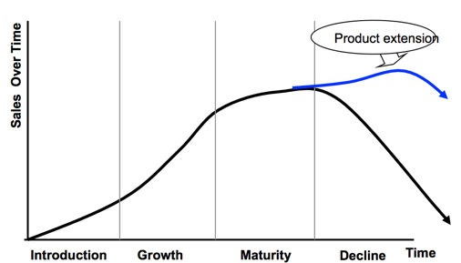
Extending the Product Life Cycle
For successful products, a business will want to do all it can to extend the growth and maturity phases of the life cycle, and to delay the decline phase. To do so, it may decide to implement extension strategies - which are intended to extend the life of the product before it goes into decline.
Examples of extension strategies are:
- Advertising – try to gain a new audience or remind the current audience
- Price reduction – more attractive to customers
- Adding value – add new features to the current product, e.g. improving the specifications on a smartphone
- Explore new markets – selling the product into new geographical areas or creating a version targeted at different segments
- New packaging – brightening up old packaging or subtle changes
Evaluating the Product Life Cycle Model
The product life cycle model is by definition simplistic. It is used to predict a likely shape of sales growth for a typical product. Whilst there are many products whose sales do indeed follow the classic shape of the life cycle model, it is not inevitable that this will happen. For example, some products may enjoy a rapid growth phase, but quickly move into a decline phase if they are replaced by superior products from competitors or demand in the market overall declines quickly. Other products with particularly long life cycles seem to enjoy a maturity phase that lasts for many years.

