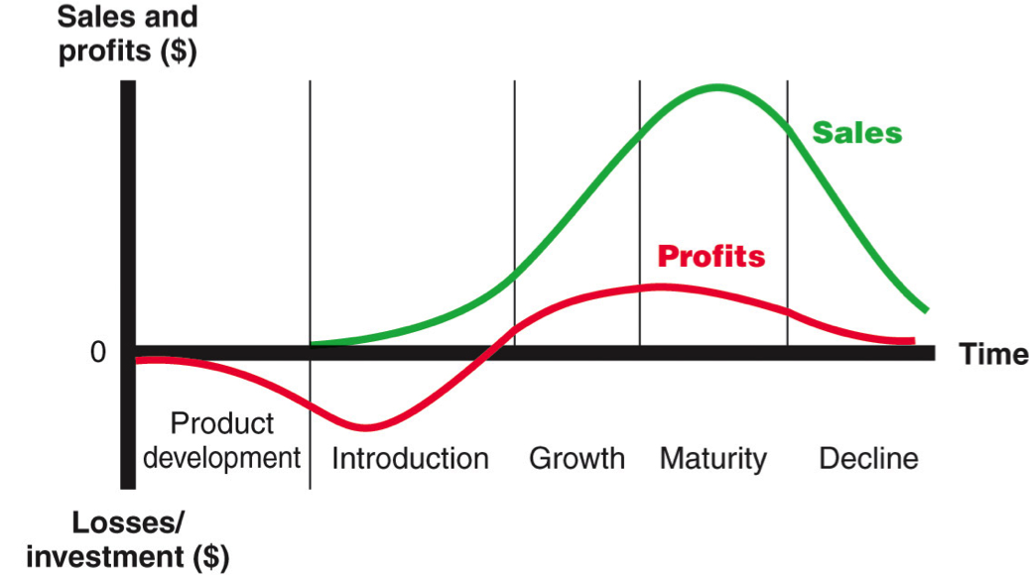
The Product Life Cycle (PLC)

Product development
In this initial stage, the idea for the product is developed and tested to see if it will work. This may involve building a prototype and seeking market feedback. This stage may take several years and is a drain on a business’s finances as they are spending money on the product but receiving nothing back from sales.

Introduction
Introduction begins when the product is launched and sales begin. It can involve a lot of expenditure on promotion as businesses need to convince distributors to stock their product. Sales are likely low at this point but costs will still be high.

Growth
Growth is experienced when the product starts to sell faster, customers are beginning to buy more of it and it is becoming successful. At this stage costs should fall but revenue should rise.

Maturity
At this stage the rate of sales begins to slow down. Revenue is likely to still be high and therefore the business should use extension strategies in order to keep the product at this stage for as long as possible.

Decline
Decline occurs when sales starts to fall. At this stage the business the business will not be spending any money developing or marketing the product, but they have to face the difficult decision of when to cease production and concentrate on other products.

