Handout – types of branding
There are three different types of branding that businesses make use of:

Family branding - Products distinguished under a company heading, e.g. Apple’s product mix consists of iMac, MacPro, AppleTV, iPod, iTunes and iPhone
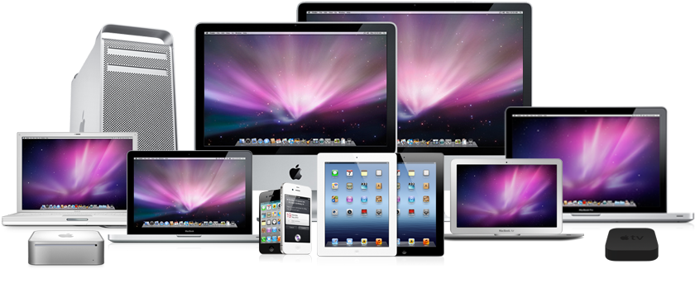

Line Branding - Products distinguished from other producers’ products e.g. Coca-Cola who separate their products into separate brands, such as Coke, Fanta, Dr Pepper.
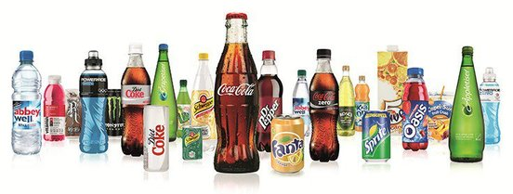

Own Branding - This is a product which is sold under the brand name of a supermarket chain or other retailer rather than under the name of the business which manufactures the product e.g. Tescos everyday value

