Unit 2: Developing a Marketing Campaign

Revision Survival Guide

Section One: Aims and Objectives

Aims = The overall goal/vision of the business e.g. “To become the fastest growing Ice Cream brand in the UK”

Objectives = The strategies that you use to achieve the overall Aim

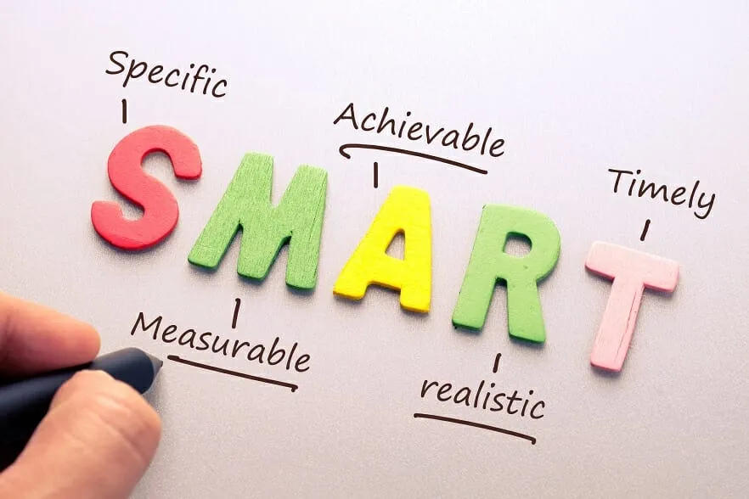
Aims and Objectives should be SMART

Specific - Be precise about what you are trying to achieve, statements such as “increase sales” is not enough. “Increasing the sales of Mars Bars by 15%” would be a specific objective.

Measurable - Using percentages or sales figures makes the objective measurable, so the business can clearly see if they have been successful.

Achievable - Having achievable goals makes setting targets worthwhile, setting an unachievable goal could damage staff morale. E.g. Setting an objective of “earn a sales turnover of £1 Billion” for a small cafe would not be an achievable goal.

Realistic - A realistic goal has to be within the capability of the business. E.g. “develop 10 new products in six months” may not be a realistic goal for a small business.

Time-Bound - Placing a time limit on your objective keeps employees focused on the task and ensures the objective is delivered within a reasonable timeframe e.g. “Increase our Instagram followers by 50,000 within the next six months”

Revision Activities

- Rewrite the following objectives to make them SMART

- Increase sales

- Increase our Youtube subscriber count

- Achieve a high customer satisfaction score

- Research current trends within the following industries and write an overall Aim with three SMART objectives;

- Wearable Technology

- Organic Food

- Streaming Services

Section Two: Market Research

Primary Research

Primary Research is research conducted by the business directly. This may include;

- Observations of staff and customers
- Questionnaires and Surveys
- Offering free samples in exchange for feedback

Advantages | Disadvantages
The business has control over the research to ensure it is providing relevant data. | Respondents can often be dishonest in their responses.
The data gathered will be up to date as it is being freshly collected. | Data can often be time consuming to gather and analyse
Your business is the only business to have the data, creating an advantage over competitors. | Primary research can often be expensive to gather and analyse.

Secondary Research

Secondary Research is research gathered from existing sources. This may include;

- Newspaper articles
- Websites
- Market Reports (e.g. Mintel)

Advantages | Disadvantages
Is often very easy to gather | It is harder to judge if the research is trustworthy.
Often free or inexpensive | The information may be out of date
Can use the expertise of specialist market research companies to discover information the business would not have found alone. | The research may be from an unreliable source.

Reliability

Reliability relates to how easily the research could be repeated and provide similar results. Here is an example;

Regina attends a local music festival that is being held as a one time event. She asked 100 people their opinions on a new alcoholic beverage and got mostly favourable opinions. What would the potential issues be with this sample and the results it would generate?

Validity

Validity is a measure of how relatable the research is to the overall research objectives. Using invalid data can confuse the research process and lead to poor decision making. Here is an example;

James has been tasked with finding out people’s opinions on a new flavour of hot chocolate and gives out free samples in a town centre. He follows up with a questionnaire that asks for the participant’s;

- Age/Gender/Occupation
- What their favourite colour is
- What types of movies they watch
- Their favourite holiday destination
- If they have any pets
- How often they drink hot chocolate

Which of these questions are valid in relation to the aim of the market research? What are the issues with asking these questions?

Task - Conduct secondary research into an industry of your choice, summerise your findings and discuss how reliable and valid the information is and the quality of the sources of information.

Section Three: Justification (Situational Analysis)

In this section of the exam, you are justifying the basis for your marketing campaign by using situational analysis. We are going to focus on SWOT, PESTLE and Porter’s Five Forces.

SWOT

A SWOT analysis a simple but allows you to quickly analyse the business’ situation. A SWOT analysis is made up of;

Strengths - Strengths are the factors that assist the business in being successful. This may include; staff knowledge, reputation, the assets the business owns and more.

Weaknesses - Weaknesses are factors that may cause issues for the business, these may include; a lack of staff experience, lack of assets or money.

Opportunities - An opportunity is what the business can take advantage of to increase their success. Opportunities may include; the closure of a competitor, trends, such as healthy eating and veganism, changes in laws and regulations.

Threats - Threats are factors outside of the control of the business that may damage the business going forward. These may include; New laws and regulations (e.g. Covid-19 restrictions)

PESTLE

A PESTLE analysis is a simplistic way to examine the external factors that may impact on the success of a business.
Political - Political factors can include local, national and international governments. E.g. Covid restrictions, political instability causing investors to hesitate, government initiatives such as weight loss campaigns.

Economic - Economic factors may include; changing interest rates, inflation, the local economy, share price.

Social - Social factors may include; changes in lifestyles e.g. a healthier approach, dairy free, vegan, social trends e.g. fashion, aging population.

Technological - Technological factors may include; advances in technology, automation (use of robots), faster manufacturing, new apps on smartphones.

Legal - Legal factors may include; changes in law, new laws, laws such as the Equality Act 2010 or GDPR 2018.

Environmental - Environmental factors may include; pollution, recycling, carbon emissions, global warming.

Porter’s Five Forces

Power of the Buyers - How much influence your customers have on your business. If there is a lot of choice in the market, buyers can choose where to shop, making it hard for the business to stand out.

Power of the Suppliers - How much influence your suppliers have on your business. A large business, such as Tesco, have a lot of power over their suppliers whereas a smaller business, such as a local baker, has limited power to influence their suppliers, finding it difficult to negotiate prices.

Competitive Rivalry - How many competitors are there in the market place? Are they well established? How will they make it difficult for your business to compete? E.g. the fast food industry has many competitors whereas specialist collectables retailers are more limited.

Threat of Substitutes - How easily is your product replaced with a competing but different product. E.g. if you are selling low calorie chocolate, could your customers purchase alternatives, such as low calorie gummy sweets?

Threat of New Entrants - How easy is it for new businesses to set up and compete against you? Large businesses, such as fast food chains, will be hard to compete against due to the large cash investment and resources needed. Smaller businesses, such as hair salons, are much easier to set-up and can be competed against swiftly.

Task - Complete a SWOT, PESTLE and Porter’s Five Forces for Amazon, being as detailed as possible. Focus on their most recent marketing campaigns.

Section Four: The Marketing Mix

The Marketing Mix consists of the 7Ps, including;

- Price
- Product
- Promotion
- Place
- People
- Process
- Physical Evidence

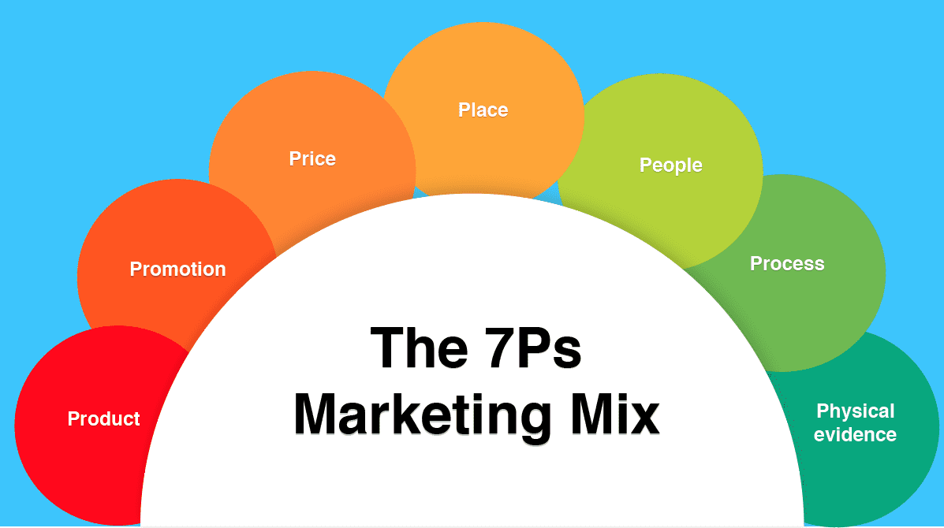

You can use this link to refresh your knowledge on the 7Ps of the Marketing Mix

Task - Analyse the Marketing Mix for a large clothing business of your choice, making it as detailed as possible. Make suggestions as to how the business could improve their Marketing Mix. Focus on the benefits to the overall marketing efforts of the business to having this strategy in place.

Section Five: Selecting Marketing Media, Budget and Time Scales

You have been asked to create a marketing campaign for a new flavour of Milkshake from a brand that currently sells candy aimed at teenagers. The campaign must run for 12 weeks (within the same 12 month period) and your maximum budget is £30,000. You have been given the following choices, approved by the marketing manager;

Type of Media | Cost | Amount of Budget Being Allocated | Number of Weeks/Time of Year | Justification
Instagram Posts | £250 per post
Youtube Ads | £400 per post
Billboards | £1000 a week
National TV Campaign (off peak) | £3000 a week
Newspapers | £8000 a month
In-store Posters (ASDA) | £2000 a month

Now that you have planned out your campaign, produce a Gantt chart to represent your campaign, showing the director of the business your strategy. Justify your time scales, explaining why you have chosen the times of the year and durations.

